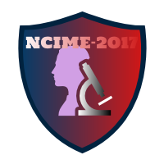

**Coordinators**

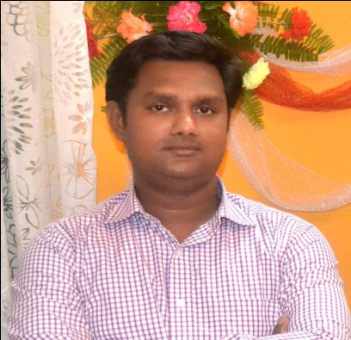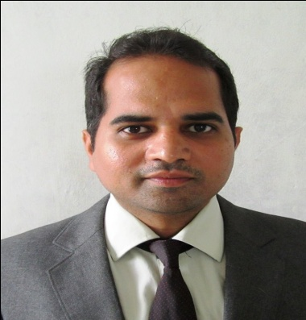

**Prof. A. P. Ogale Prof. S. V. Karankoti**

**Co-Coordinators**

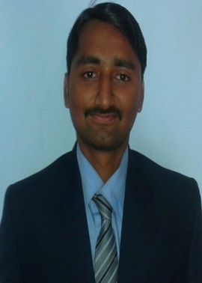 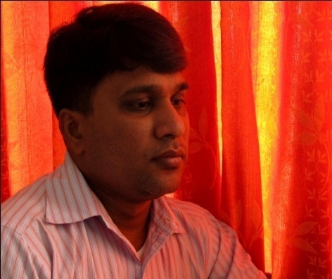

**Prof. M. N. Chougule Prof. L. P. Puranik**

**(Department of Mechanical Engineering, SIT, Lonavala)**